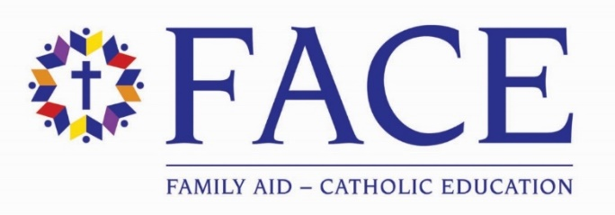

FACE 2022-2023 Named Scholarship Information and Award Recipients
Establishing a named annual scholarship is an act of generosity that allows you to make a difference in a particular's student's educational path. You may establish an annual scholarship to honor a loved one or memorialize an important person in your life. The scholarship will bear the name of your wishes, i.e. The Abigail McCabe Face of the Future Annual Scholarship. You will also choose whether you want to fund an elementary school student ($5,000) or a secondary student ($7,500).
How it works: A member of the FACE team will work with you to write a Gift Agreement that ensures your scholarship is awarded according to your wishes. You may name the scholarship to honor a loved one or memorialize an important person in your life. Aside from naming the scholarship, you have the option of choosing a school in Alameda or Contra Costa County. You may select an elementary school, secondary school, or a particular institution.
If you have any questions about establishing a FACE of the Future Annual Scholarship, please contact Terri Porter at tporter@oakdiocese.org.
Thank you for investing in the formation and future of bright young students by supporting Catholic education. Your gift makes a difference!

Elementary Students

Genesis Finley – 7th- St Leo the Great
The Karleskind Family FACE of the Future Annual Scholarship

Andrew Garcia-Valencia- 5th Grade – St David School
The Gard Family FACE of the Future Annual Scholarship

Gianna Rubio-2nd Grade-Queen of All Saints School
The King Family FACE of the Future Annual Scholarship

High School Students

Aniya Lewis-11th Grade-Bishop O’Dowd High School
The Kelly Family FACE of the Future Annual Scholarship

Nathaniel Tejano- 9th Grade- Salesian College Preparatory High School
The Black Family FACE of the Future Annual Scholarship

